84824 Gillian Counter Stool
Product Instructions for:

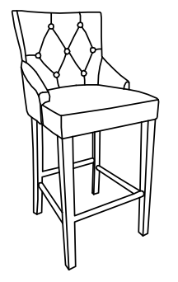

WARNING!

-Children should not use this product without supervision.
-Do not stand on chair, or use chair as a ladder.
-Only one person should be on the chair at a time.
-Prior to use, thoroughly tighten all screws and bolts.
-All screws and bolts should be periodically inspected for tightness and security. Tighten all fasteners as necessary.
-Discontinue use of this product if any portion is missing, damaged or worn.

-Failure to follow assembly instructions and heed all warnings may result in serious injury and/or death.

84824 Gillian Counter Stool

Before beginning assembly, separate all parts and carefully study the parts diagrams below. Review all parts and hardware before disposing of any packaging. You may receive extra hardware with your unit. For damaged or missing parts, or assistance assembling your product, please call toll free in the USA- 877-267-2261. Customer service is available on your purchase from 8am to 5pm Central Standard Time, Monday through Friday. Customer service is also available via email at- info@boraam.com.
Parts List

A: Back (1)
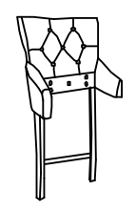

C: Front Legs (2)
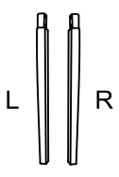

E: Front rail (1)



G: Bolt: 5/16” * 1”L (6)
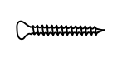

I: Spring Washer (11)
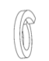

B: Seat (1)

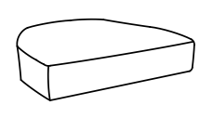

D: Side rail (2)

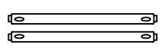

F: Bolt:M8*1-1/2’’(11)

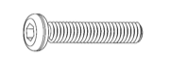

H: Flat Washer (11)

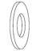

J: Allen Key (2)

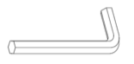

Gillian Counter Stool
Assembly Instructions

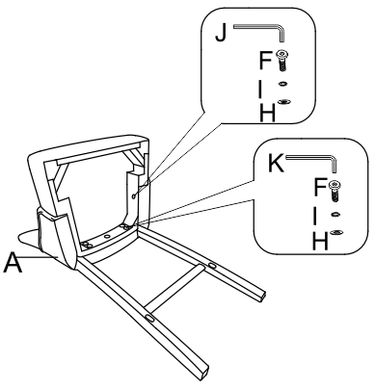

Figure 1

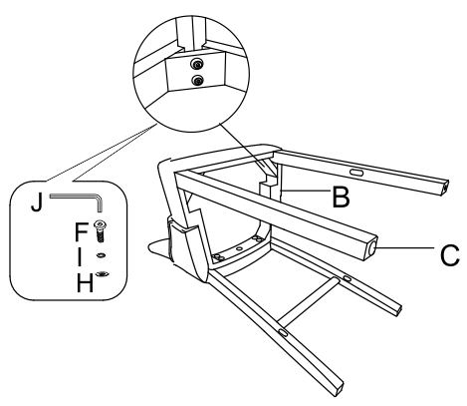

Figure 2

Step 1

Put the screws in the holes, tighten the screws, but not too tight, 90% is ok

Step 2

Put the screws in the holes, tighten the screws, but not too tight, 90% is ok.

Gillian Counter Stool
Assembly Instructions
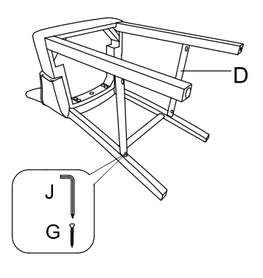

Figure 3

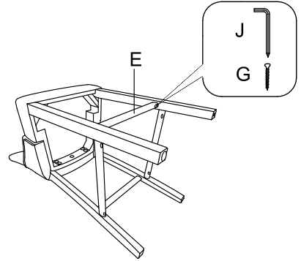

Figure 4

Step 3

Put the screws in the holes, tighten the screws.

Step 4

Put the screws in the holes, tighten the screws.

Gillian Counter Stool
Assembly Instructions

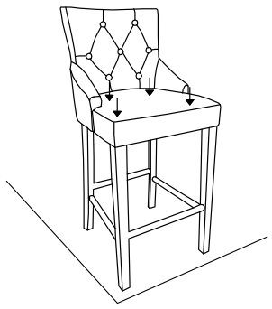

Figure 5

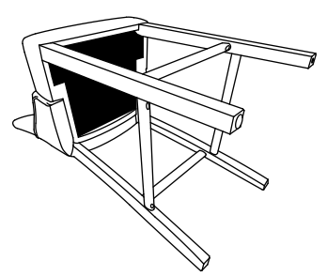

Figure 6

Step 5

Put the screws in the holes, tighten the screws, but not too tight, 90% is ok.

Step 6

Finally,Stick the black part on the seat.

